

TEAM OVER ACHIEVERS

Project for MusalaSoft

July 2021

**Table of Contents**

1. Team Members 2

2. Link to the repository 2

3. Used technologies 3

4. Topic 3

5. Basic architecture of the project 4

6. Link to the database script 5

7. Link to the readme file 5

8. Features 5

1.Team Members

Reneta Topalska – Back End and Front End developer, Documentation and Presentation, Website developer

* [RBTopalska18@codingburags.bg](mailto:RBTopalska18@codingburags.bg)
* Github account: RBTopalska18

2.Link to the repository:

<https://github.com/RBTopalska18/Over-Achievers-MusalaSoft-Project>

3. Used technologies:

* Visual Studio

I used C++ as programming language for the main program and Visual Studio as programming environment.

* Visual Studio Code

I used HTML, CSS and JavaScript as our programming language for the website and Visual Studio Code as our programming environment.

* Microsoft SQL Server Management Studio

I used MSSMS for the database.

* Word

On Word I wrote the documentation.

* PowerPoint

I used PowerPoint for the presentation.

* Github

To store the project I used Github.

4. Topic

I am developing a program, which will help anyone to reserve a ticket for a flight from Italy, France and Germany.They can choose if they want to fly with cheaper tickets, to choose the time, destination or to see all the flights. The program will be a way for them to organise there trips.

5. Basic architecture of the project

* The program have 3 main cities that can use it. They are: Venice, Paris and Berlin.
* The information in the program is real.
* When you reserve a ticket it goes to the database.
* 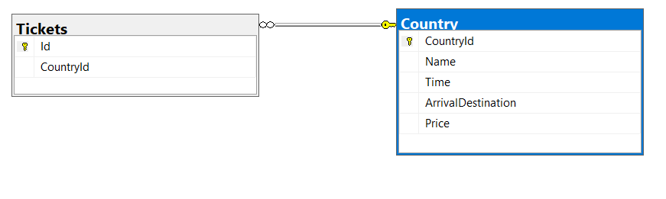Data base structure:
* 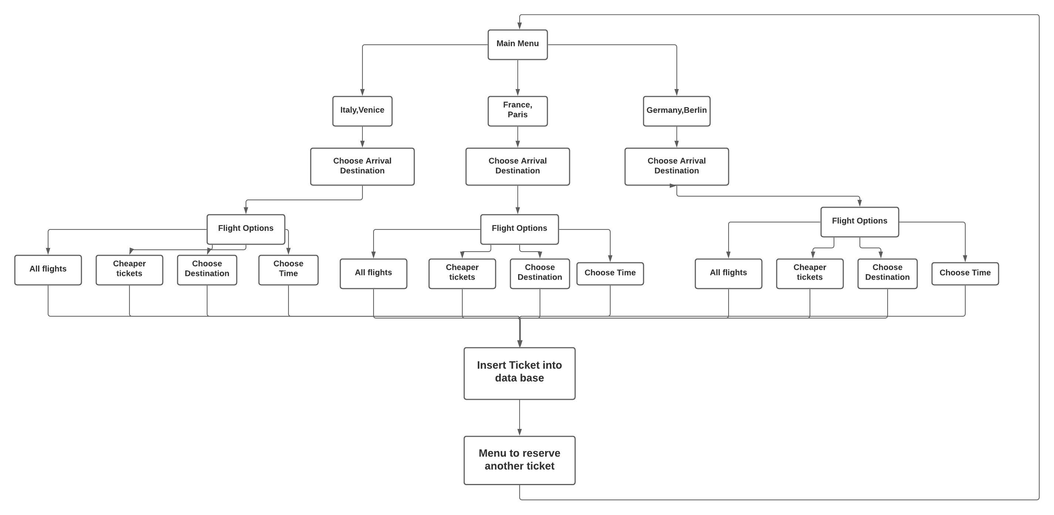Diagarm:

6. Link to the database script

<https://github.com/RBTopalska18/OverAchieversMusalaSoftProject/tree/master/Database%20Sript>

7. Link to the readme file

[https://github.com/RBTopalska18/Over-Achievers-MusalaSoft-Project#readme](https://github.com/RBTopalska18/Over-Achievers-MusalaSoft-Project%23readme)

8. Features:

* Implement more countries and cities that can use the program
* Implement more options and update the others that already exist
* Implement more flights
* Add more information about the flights like:
  + Stops
  + Cancel flights
  + Baggage
  + Classes